**Social resilience in the Sundarbans – Context and theories**

The Sundarbans, located in the tidally active lower deltaic plain of the Ganges-Brahmaputra-Meghna (GBM) basin, hosts the largest contiguous mangrove forest and the only mangrove tiger habitat in the world. It has been a central point of focus in international forums such as the IPCC, WWF, IUCN. Conservation of this ecological hotspot focuses on tigers, ecotourism, emigration, mangrove transplantation, construction of concrete embankments and funding approvals for cyclone centres. More recently, ‘managed retreat’ as an adaptation measure has received renewed attention in scientific and policy circles (Danda 2019).

Our decade-long research and historical understanding of the delta demonstrates that while media uses hyperbolic adjectives to portray immediate impacts of super cyclones on communities, civil engineers and technocrats still find meaning in hydrological interventionist regimes, concretizing this clayey terrain – with severe cascading implications on the social ecology of the Sundarbans. As a result of a co-evolving process, the ecological characteristics of a region influence human social and economic systems. This is why a number of academics have previously suggested that the focus of scientific research should be on interrelated "social-ecological systems" (Berkes & Folke, 1998). A SES is an ecological system that is intimately connected to and impacted by one or more social systems (Anderies, Janssen, & Ostrom, 2004). Additionally, SESs are multi-layered schemes that deliver crucial service to society, like the provision of fiber, food, and energy. Taken as an example, small-scale inland and coastal fisheries are significant social-ecological systems in many developing nations, offering vital ecosystem services and possibilities for a living to some of the world's poorest and vulnerable communities. Different research methodologies have been created and used in numerous studies that explicitly take into account the relationship between the social system and the ecological system. The idea of social-ecological systems (SES) has developed to emphasize the relationships between the ecological and human aspects.

An SES is illustrated schematically with its ecological component, social component, and interphase, which includes links and feedback mechanisms (Beatrice, 2006). The Sundarban Mangrove Forest (SMF) includes three key components: a social component (people), an ecological component (mangrove resources), and an intermediary component (local ecological knowledge, stakeholder interests, and roles of middlemen or money lenders).by which they are connected in interaction. The SMF therefore can be described as a SES.

In our field-based practical-empirical projects in Sundarbans, we critique the dominant apocalyptic as well as interventionist conservation discourses and aim to foreground the (trans)local stories of resilience to the global climate risks by bringing to the fore everyday lived realities – struggles, resistance, adaptation and adjustment 'tactics' (Ivars 2020) to dwell in the delta. Borrowing from political ecology of risks scholarship (Wescoat 2015), we argue and explain why the ‘multiple disruptive risks’ perspective is historically contingent and socially accommodative over the ‘single disaster’ approach (Illustration 1, left side) that relies upon mainstream disaster mitigation mechanisms of ‘predict and provide’ (Adger 2006), projecting communities as passive spectators and victims of climate change. Contrary to this capital-intensive, ‘same size fits all’ disaster management and modelling, we assert that a ‘social resilience’ framework, accommodating inputs from local communities (Illustration 1, right side) can unleash possibilities through which sustained solution strategies of dealing with climate risks and ‘dwelling’ in the delta can be forged and fostered. We are influenced by Pemberton et al. 2021 paradigm of ‘staying’ as climate change adaptation strategy.

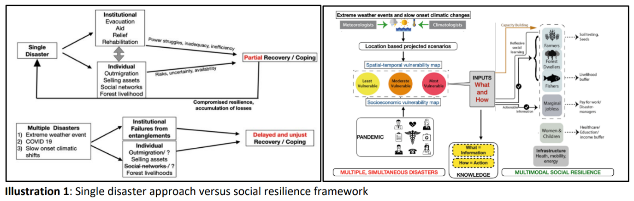

While Adger (2000: 361) provides the very first definition of social resilience “as the ability of communities to withstand external shocks to their social infrastructure,” Keck and Sakdapolrak (2013: 8) argue that all “definitions of social resilience concern social entities—be they individuals, organizations or communities—and their abilities or capacities to tolerate, absorb, cope with and adjust to environmental and social threats of various kinds.” Thus, social resilience is an outcome of the adaptive capacities of society to tackle disasters through deliberate planning strategies and implementation, relying upon the skills and know-how of the coupled social-ecological infrastructures. This provides the social system with a better ability to ‘respond and recover’ (Cutter et al. 2008) from disasters. Learning from the past, the anticipatory capacities of social actors function as one of the enabling conditions to absorb shocks which in turn, facilitates the capacity of the social system to reorganize, transform and learn, and appropriately respond to disasters. The impact remains deep-rooted through preparatory concerted actions and constant efforts in experimentation and improvisation of tactics and strategies. Contrarily enough, catastrophes may often lead to opportunities through which “capacities of individuals, groups and organizations to deal with threats more competently” can get enhanced (Obrist et al. 2010: 291).

The three capacities of social resilience include: coping capacities, adaptive capacities and transformative capacities (Keck and Sakdapolrak 2013). Coping capacities are the absorptive abilities of people to overcome immediate threats by using existing resources directly available to them. Adaptive capacities are the preventive mechanisms where people learn from the past and prepare for the future to adjust livelihood options accordingly. Transformative capacities reflect people’s ability to mobilize access to resources and assistance from the wider socio-political support system—the state and the civil society. This also includes participation in decision-making processes and innovating and shaping institutions, harnessing individual welfare and societal robustness to address future crises. Thus, while coping involves tactical agency based on short-term rationales, adaptation entails strategic agency and more long-term planning, and transformation incorporates progressive change – along structural (fundamental ways in which production and consumption are organized and governed), systemic (intentional change to steer complex systems towards normative goals) and enabling approaches (fostering values of agency, justice and capabilities) towards transformative change (Scoones et al. 2020).

Within this theoretical-conceptual context, we argue that it is important to empirically map, document, activate and disseminate ‘situated adaptive practices’ (SAPs) with the larger aim of exploring and eliciting ‘response-ability’ (Haraway 2016) of local communities to bounce back and deal with disruptive risks in the delta. Through the application of fundamental principles of knowledge coproduction (Norström et al. 2020) and action research, our conviction to climate justice interrogates binaries such as: ‘indigenous’ vs ‘modern’, ‘state’ vs ‘local’, ‘solid’/’land’ vs ‘liquid’/’water’ and ‘vulnerability’ vs ‘resilience’ by factoring in temporality and fluid understandings of the ‘social’ tapestry, constantly being manufactured and manipulated by dynamic-mediating inter and ‘intra-actions’ (Barad 2007) across multiple actors, events and enacting.

By analyzing and documenting local stories of resilience during the global Anthropocene, drawing upon transdisciplinary knowledge coproduction through multimodal-participatory methodologies from the remotest island village(s) the Sundarbans, our action research is committed to co-design and co-implement ‘pervasive and persuasive pathways’, largely co-agendizing interactive (transboundary) adaptive governance by fostering multi-agency and actions.

References

Adger, W. N. (2000). Social and ecological resilience: are they related? Progress in Human Geography 24(3), 347-364.

Adger, W. N., Hughes, T. P., Folke, C., Carpenter, S. R., & Rockstrom, J. (2006). Social-ecological resilience to coastal disasters. Science 309(5737), 1036-1039

Anderies, J. M., Janssen, M. A., & Ostrom, E. (2004). A framework to analyze the robustness of social-ecological systems from an institutional perspective. Ecology and society, 9(1).

Barad, K. (2007). Meeting the Universe Halfway: Quantum Physics and the Entanglement of Matter and Meaning. Durham: Duke University Press.

Berkes, F., & Folke, C. (1998). Linking social and ecological systems for resilience and sustainability. Linking social and ecological systems: management practices and social mechanisms for building resilience, 1(4), 4.

Cutter, S. L., Barnes, L., Berry, M., Burton, C., Evans, E., Tate, E., & Webb, J. (2008). A place-based model for understanding community resilience to natural disasters. Global Environmental Change 18(4), 598-606.

Danda, A., Ghosh, N., Bandyopadhyay, J., & Hazra, S. (2019). Managed retreat: adaptation to climate change in the Sundarbans ecoregion in the Bengal Delta. Journal of the Indian Ocean Region 15(3), 317-335.

Haraway, D. J. (2016). Staying with the Trouble: Making Kin in the Chthulucene. Durham: Duke University Press.

Ivars, B. (2020). Alluvial tactics: land access and control on the Ayeyarwady River. Journal of Burma Studies 24(1), 37-78.

Keck, M., & Sakdapolrak, P. (2013). What is social resilience? Lessons learned and ways forward. Erdkunde, 5-19.

Norström, A. V., Cvitanovic, C., Löf, M. F., West, S., Wyborn, C., Balvanera, P., ... & Österblom, H. (2020). Principles for knowledge co-production in sustainability research. Nature sustainability, 3(3), 182-190.

Obrist, B., Pfeiffer, C., & Henley, R. (2010). Multi-layered social resilience: a new approach in mitigation research. Progress in Development Studies, 10(4), 283-293.

Pemberton, S., Furlong, B. T., Scanlan, O., Koubi, V., Guhathakurta, M., Hossain, M. K., ... & Roth, D. (2021). ‘Staying’ as climate change adaptation strategy: a proposed research agenda. Geoforum 121, 192-196.

Scoones, I., Stirling, A., Abrol, D., Atela, J., Charli-Joseph, L., Eakin, H., ... & Yang, L. (2020). Transformations to sustainability: combining structural, systemic and enabling approaches. Current Opinion in Environmental Sustainability 42, 65-75.

Wescoat, J. L. (2015). Political ecology of risk, hazards, vulnerability, and capacities. In The Routledge handbook of political ecology (pp. 293-302). London: Routledge.